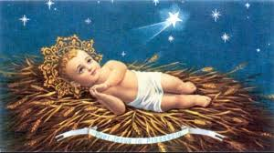
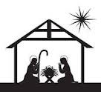
CHRISTMAS SCHEDULE 2019 – Shannon Parish

Normal Daily Masses up to Friday December 20th

Tradaree Pastoral Area Reconciliation Services
Monday December 16th, 7pm in Sixmilebridge Church.
Tuesday December 17th at 7pm in Newmarket on Fergus Church.

Confessions for Christmas
After all weekend Masses December 21st and 22nd and
Christmas Eve from 12-1pm in both Church’s

Saturday 21st & Sunday 22nd Dec – Normal Sunday Mass Times

Monday & Tuesday December 23rd & 24th
10am Mass only on Monday morning in Mary Immaculate Church.
There is NO morning Mass on Christmas Eve.

Christmas Eve Masses
6pm - Mary Immaculate Church (Children & Young People.)
9pm – Both SS John & Paul and Mary Immaculate Church’s.
12am Midnight Mass - SS John & Paul Church.

Christmas Day
9am – Mary Immaculate Church.
10am – SS John & Paul Church (Children & Young people).
11am – Mary Immaculate Church.
12.15pm – SS John & Paul Church.

December 26th to December 28th
12 noon Mass in Mary Immaculate Church only
with 7pm Mass on Friday 27th December in SS John and Paul Church.
There is NO evening Mass on St. Stephen’s Day.

December 28th & 29th - Normal Sunday Mass Times

Monday December 30th – Saturday January 4th 2020
12 noon Mass in Mary Immaculate Church
with 7pm Mass on Thursday and Friday January 2nd & 3rd only.
There is NO 7pm Mass on New Year’s Eve or New Year’s Day.

Saturday January 4th & 5th 2020 – Normal Sunday Mass Times
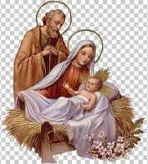
Monday January 6th Feast of The Epiphany
9am & 11am – Mary Immaculate Church
12.15pm & 7pm – SS John & Paul Church
Adoration Chapel will re-open on Tuesday Jan 7th

Wishing all our Parishioners
and all those visiting Shannon
over Christmas time

the joys and
Blessings of Christmas

and Peace, Health & Happiness

in 2020

